**ARYAMAN MISHRA**

**19BCE1027**

3)BCD TO HEX

ASSUME CS:CODE

CODE SEGMENT

START:MOV SI,5000H

MOV DI,6000H

MOV BL,[SI]

AND BL,000FH

MOV AL,[SI]

AND AL,00F0H

MOV CL,04

ROR AL,CL

MOV DX,000AH

MUL DX

ADD AL,BL

MOV [DI],AL

INT 3

CODE ENDS

END START

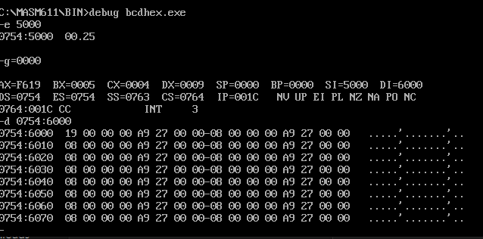

4)FIBONACCI

ASSUME CS:CODE

CODE SEGMENT

START:MOV AL,00H

MOV SI,500H

MOV [SI],AL

ADD SI,01H

ADD AL,01H

MOV [SI],AL

MOV CX,[0000H]

SUB CX,0002H

L1: MOV AL,[SI-1]

ADD AL,[SI]

ADD SI,01H

MOV [SI],AL

LOOP L1

INT 3

CODE ENDS

END START

